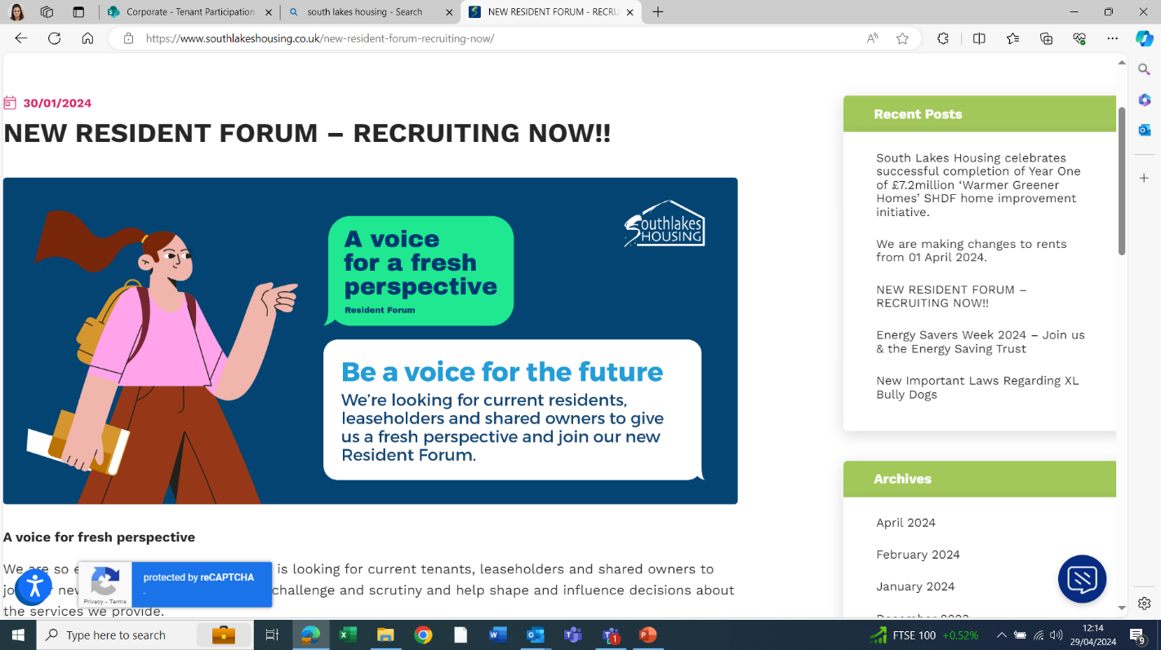

## RESIDENTS FORUM

## 23rd January 2025

6 Resident Forum (RF) members attended the meeting, and 1 RF member gave apologies. The meeting was also attended by the Chief Executive (CExec) Director of Customer Experience (DCE), The Director of Business Improvement (DBI), the Customer Experience Manager (CEM) the Customer Engagement Partner (CEP) and the Investment Delivery Manager (IDM)

* The CExec joined the meeting to discuss a private and confidential matter.
* RF members approved the minutes 3rd October as a true and accurate record.
* RF members noted the action proforma updates.
* RF members approved the ‘Involvement of Customers in Procurement Policy’.
* RF members noted and approved the minor amends to the Whistleblowing Policy.
* The CEM shared information about the Grant Application Panel (GAP). Residents, or colleagues on behalf of residents can make an application to apply for funds. Panel members review applications submitted and collective approval is sought. Examples of the use of funding this year included flower beds, winter warmth packs and communal seating. To date, this year £700 has been awarded. We would like to raise awareness of the GAP funding and increase the number of applications. We also hope to be able to access some match funding. RF members suggested a quarterly newsletter and advertising the GAP funding on the SLH website including positive stories where the funding has been awarded, and name change for GAP.
* The IDM shared an update of the 2025/26 planned maintenance programme. SLH have the following works planned.
  + Windows to 97 properties
  + 15 new kitchens
  + 21 new bathrooms
  + 31 doors
  + 55 Properties rendered
* RF members asked how work on properties is identified. IDM explained surveyors visit properties every 5 years to carry out stock condition surveys any works identified are then planned into the maintenance programme. Discussions also took place around the life spans of kitchens, bathrooms and windows.
* The DCE shared an update on the rent increase from April 2025. The rent increase is determined by a government formula, linked to the Consumer Price Index (CPI) in the preceding September plus 1%. The rent increase will ensure SLH continues to provide customers with safe, well-maintained, affordable homes and is always a balance between affordability for customers and SLH remaining financially viable and able to maintain homes and services and build new ones. The SLH Board approved 2.7%. increase from 1st April 2025.